Camp Cards for a Cause

2023 Guide

Introduction
Thank you again for your participation in Grand Canyon Council’s 2023 Camp Card sale! What I love so much about Camp Cards for a Cause is that anyone can participate in it, no matter how much or how little your unit is involved in the regular sale. Here are some more reasons why Camp Cards for a Cause is the perfect fundraiser for anyone in Grand Canyon Council:

- This year, Camp Cards for a Cause is easier than ever thanks to Facebook Fundraising! Reach more of your friends and family than ever before with ease and convenience!
- You still receive a 50% commission for every card sold! That’s right, for every $10 you raise, $5 goes right back to you to support your fundraising goals.
- Camp Cards for a Cause supports two great causes – Scouting and educators! There has never been more of a reason to give!

This guide will walk you through every step you need to take to ensure a successful Camp Cards for a Cause fundraiser. If you have any questions, please do not hesitate to reach out to me at brendan.switts@scouting.org

Yours in Scouting,

Brendan Switts
Program Executive

HOW TO START YOUR CAMP CARDS FOR A CAUSE FUNDRAISER

- Go to www.facebook.com/grandcanyonbsa 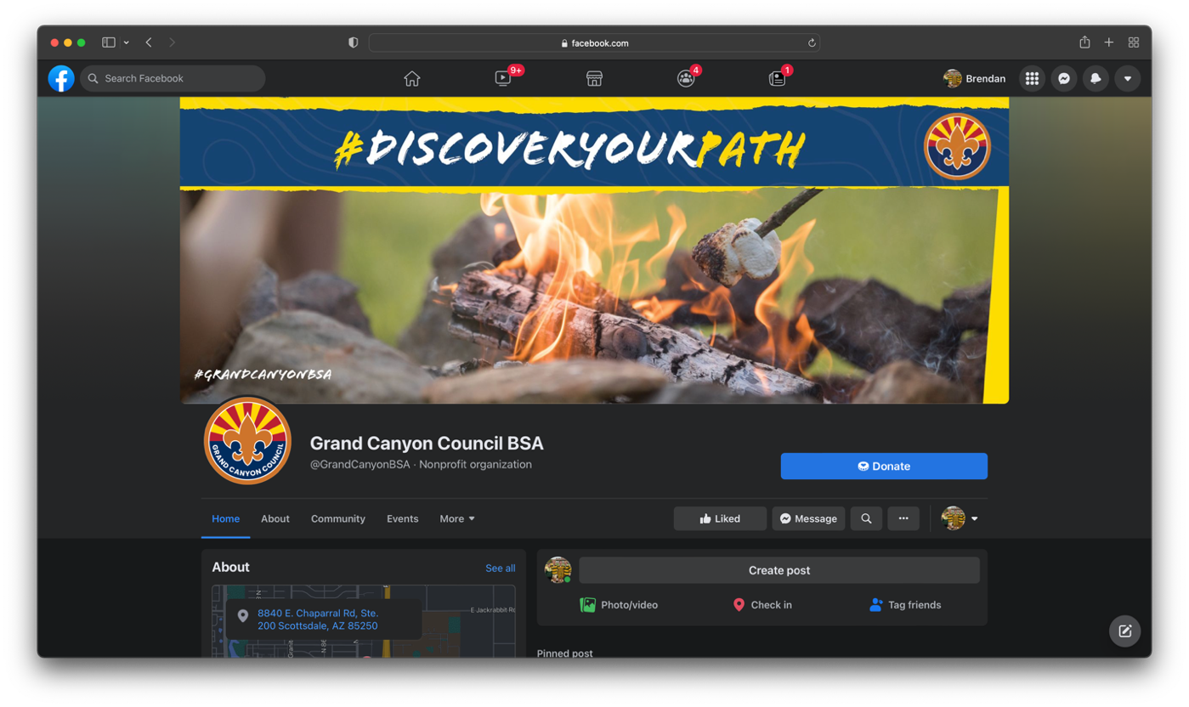
- Press “Fundraisers.” It may be in the top bar below “Grand Canyon Council BSA,” or under “More.” 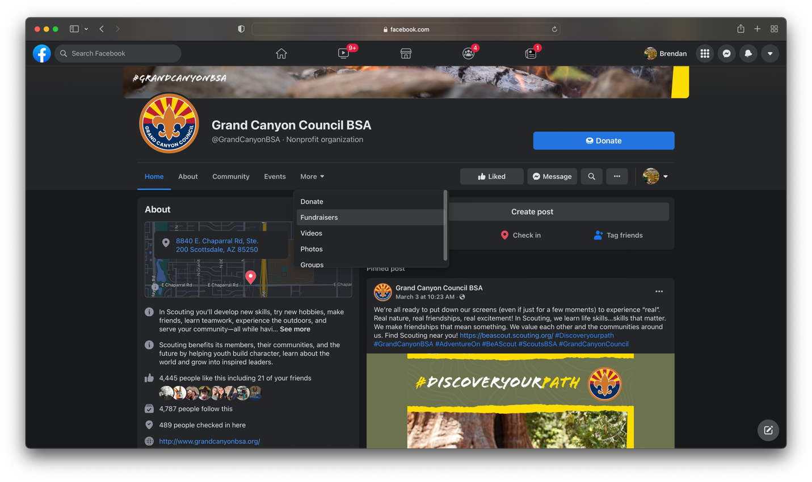
- Press “Raise Money” 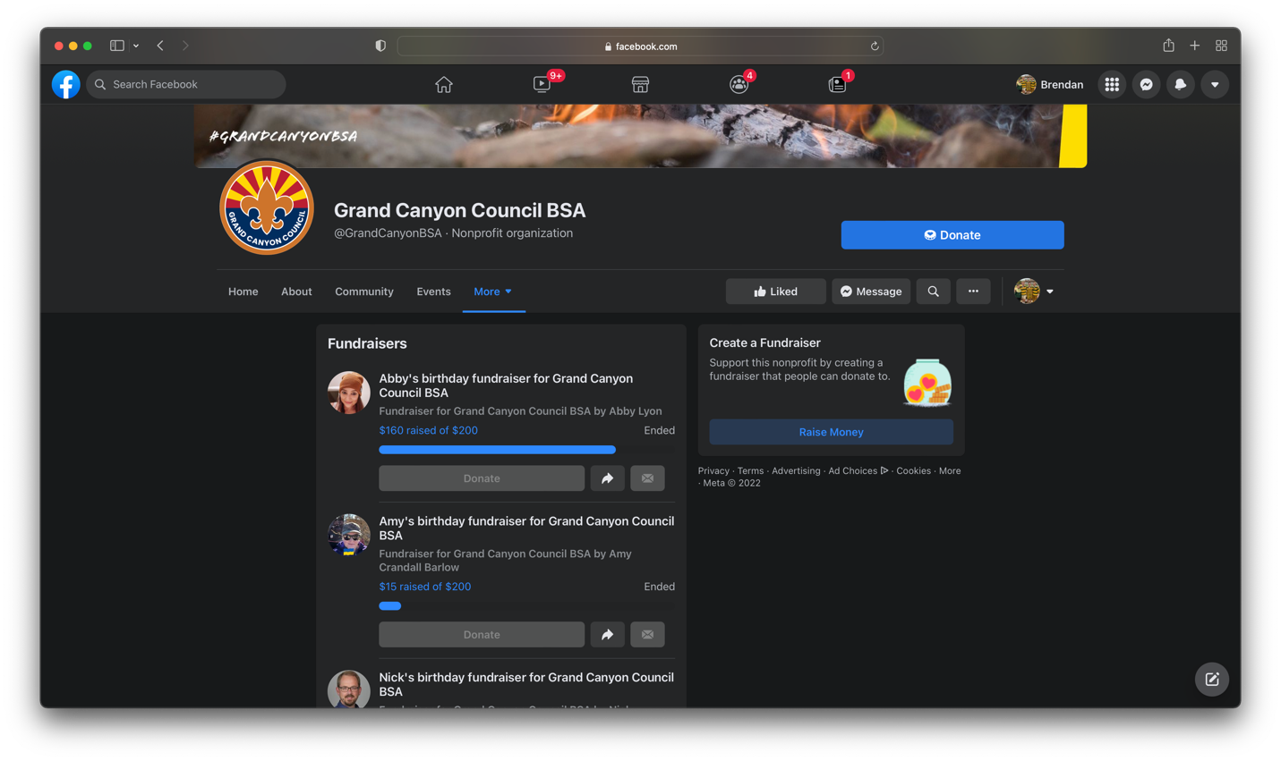
- Customize your fundraiser using the bar on the left side of your screen! Find instructions on the next page of this document. 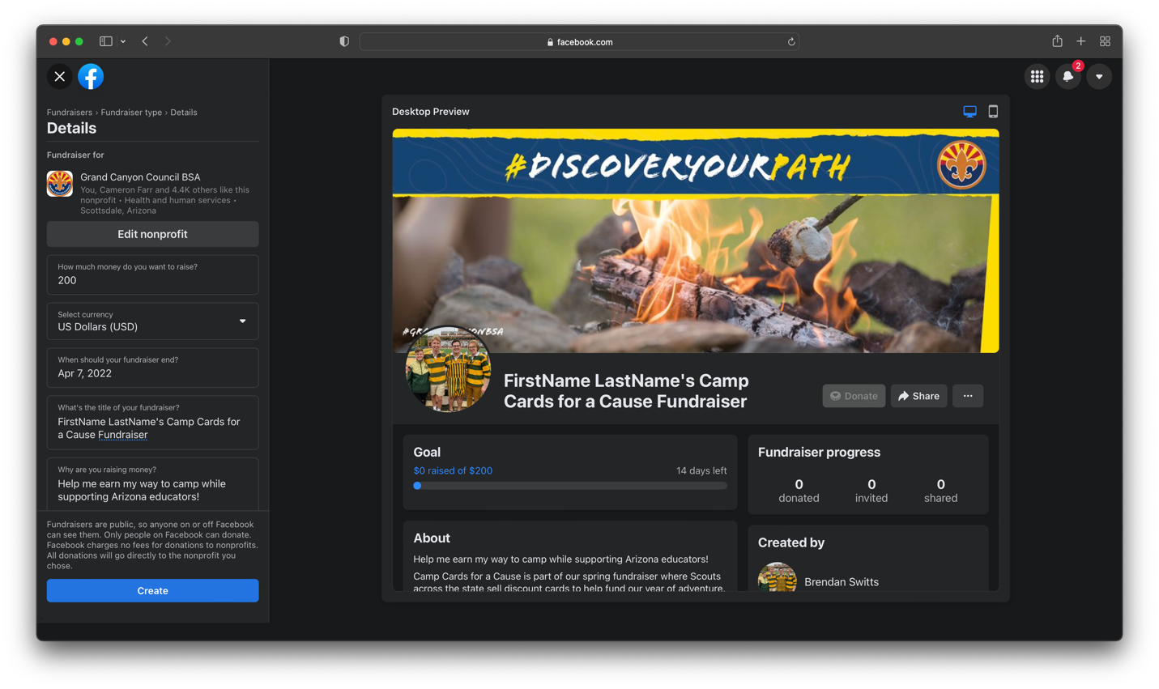

INSTRUCTIONS FOR CUSTOMIZING YOUR FUNDRAISER

- Think about who’s account you want to use to promote this fundraiser. The Scout’s account is not always the best choice (if it is even an option). Since you can change the name of the fundraiser to whatever you want, we recommend using a parent or guardian’s account in most cases.
- Decide “How much money do you want to raise?” Make this goal realistic and based on your actual fundraising goals. What are you raising money for? Summer Camp? Unit dues? Please be as specific if possible. Remember, you receive a 50% commission for Camp Card sales, so this amount should be twice as much as you need.
- Please make sure that the “Select currency” section is set to “US Dollars (USD).
- “When should your fundraiser end?” We suggest a two-week Camp Cards for a Cause sale so that there is a sense of urgency (but feel free to set it for longer). We have also written our sample posts (which you can find later in this document) based on this schedule.
- “What’s the title of your fundraiser?” Please name your fundraiser:
FirstName LastName’s Camp Cards for a Cause Fundraiser
This is the only way to guarantee that you receive your commission.

- “Why are you raising money?” Try to be as specific as possible and emphasize that this fundraiser is supporting two great causes: Scouting and educators. Here is a sample of what you can write:

Help me earn my way to camp while supporting Arizona educators!

Camp Cards for a Cause is part of our spring fundraiser where Scouts across the state sell discount cards to help fund our year of adventure. This year, I am trying to raise money so I can *insert reason here*.

In case you don't want a Camp Card for yourself though or want to give more to help me reach my goal, Grand Canyon Council created Camp Cards for a Cause. For every $10 I raise here, $5 will go towards my goal, and a Camp Card will be donated to a local educator! The rest of the funds will be used to improve summer camp properties, keep camp fees low, and provide support to other Scouts in need!

Your support means so much to me, and I hope you will be able to help me reach my goal. If you would like to learn more about Scouting in Arizona, you can visit grandcanyonbsa.org

Facebook takes care of the donation processing with no fees.

- Cover Photo: We recommend updating this section with a good photo of you having fun in Scouting!
- Press “Create”

You did it! Now, let’s talk about your fundraiser update posts!

TIPS AND TRICKS FOR A SUCCESSFUL FUNDRAISER

All right, now that you have created your fundraiser, what’s next? Here are some tips and tricks that you should do to help make your Camp Cards for a Cause fundraiser a success.

- Scroll down to “Invite Friends,” and then invite them! 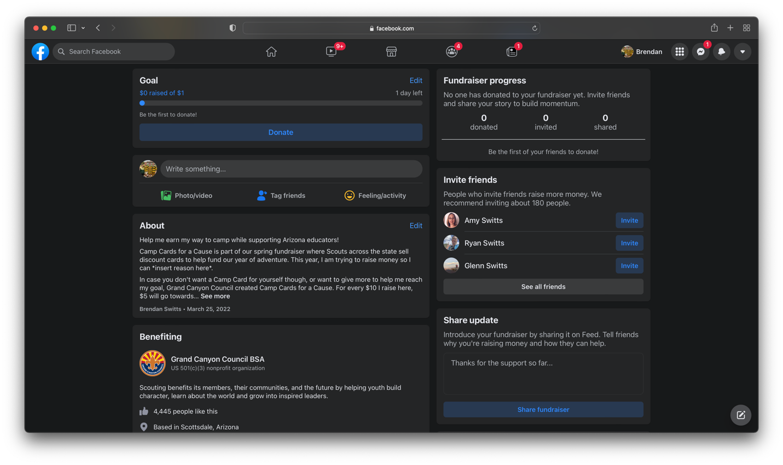
This is something we recommend you do as soon as you start your sale! Think about who is most likely to support you and ask for their help!
- Fundraiser Link: Share the fundraiser link with those who you know want to support you but may not check Facebook very often. 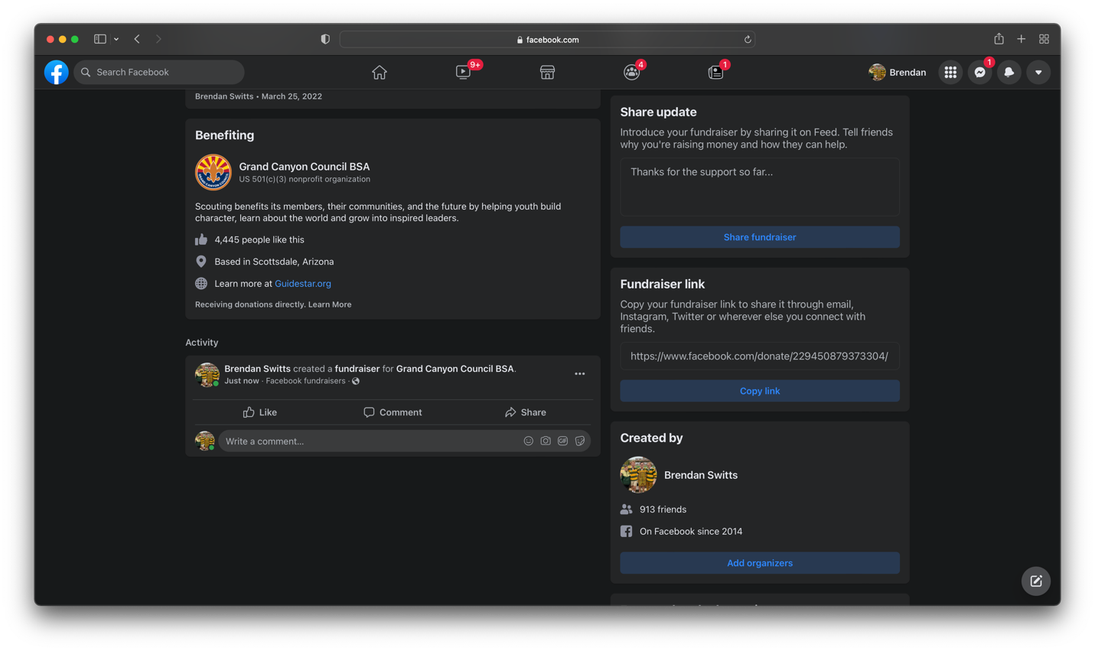
This could be friends, family members, your best popcorn buyers… Share this link directly with them (via email or text) or on your other social media accounts!

- Share Update: Introduce your fundraiser by sharing it on Feed. Tell friends why you’re raising money and how they can help. We recommend posting at least 6 times during your two-week fundraiser to help reach this goal. Remember, the highest performing posts are short and meaningful. Every Scout’s experience is different, and different style of posts are appropriate for different ages, but here are some samples to get you started:
Post 1: Your first post will be automatically created as soon as you start your fundraiser. It will include the summary you wrote, so make sure it is a good one!
Post 2: Talk about your favorite Scouting memory and end your story with an invitation to donate and help you do it again. For example:

  - I am raising money to go to Camp Geronimo! It was hard being away from home for the first-time last summer, but I had a great week and cannot wait to go back. My favorite part was the cooking merit badge, where I learned how to make pizza on a camping trip! Want to help me do it all again? Support my Camp Cards for a Cause fundraiser before you’re out of time!

Post 3: Give an update on how your fundraiser is going and ask others to join in!
- There is only one more week to support my Camp Cards for a Cause fundraiser, and we are almost halfway towards reaching my goal! I love being involved in Scouting, and opportunities like this help make it affordable for me and my family. And don’t forget – for every $10 I raise, a Camp Card is given to a local educator!
Post 4: Write a post about the cause:
- One of my favorite parts of Camp Cards for a Cause is that it supports two great causes! Teachers are such an important part of our community, and this is one way that I can support them while still working towards my goal to earn my way to camp. For every $10 raised, a Camp Card is given to a local educator, so make sure to give your $10 (or more) today!

Post 5: Write another post about your Scouting experience.

- Scouting is full of fun activities like camping trips that get me excited every month to get outdoors, but another reason I love being a part of Scouting are the lessons and values I learn from my adult leaders and other Scouts. This year, I am really excited to go to National Youth Leadership Training, where I will learn how to be a better leader both in my unit and my daily life!
Post 6: Write a “last call” post.
- Time is running out, and we are so close to meeting my fundraising goal! What can you do to help me cross the finish line? Have you donated yet? Have you shared this post with your friends? Anything helps!

Other Post Ideas:

  - Publicly thank someone who made larger-than-normal donation. Remind your friends/followers that for every $10 raised, a Camp Card is given to a local educator.
  - Make a short video (in your uniform!) asking for support! Videos are some of the most viewed posts on Facebook.

- Post in your fundraiser to thank those who already donated and invite them to share your fundraiser. Here are some good ways you can do this:
  - Give updates on your progress. “As of today, we are ¾ of the way towards my goal! Thank you all for your support!”
  - Invite them to share your fundraiser: “Thank you all for your donation! Have you shared this fundraiser with others yet? Every bit helps!”
  - Comment on their posts after they have donated. Thank them for their support. This lets your supporters know that you appreciate them.
- Make sure to give a final update thanking everyone for their help. Here are some things you should consider including:
  - How many educators are receiving Camp Cards from your fundraiser.
  - How much money you raised towards your goal.
  - Where the rest of the money went. “The rest of the funds will be used to improve summer camp properties, keep camp fees low, and provide support to other Scouts in need!”

FINAL NOTES

Please contact Program Executive Brendan Switts at brendan.switts@scouting.org with any questions or concerns.

Commissions will be deposited into your unit’s account after the end of the Camp Card sale. You will receive an email notification when this has been done.
Thank you all for your hard work!

