LIGHT THE NIGHT
Take-Aways:
1. Since most den and pack meetings are held in the evening, identifying ways to maximize this aspect using after-dark activities is to our advantage.
2. Fun activities that can be done in the dark can help young Scouts allay their fears and prepare them for future camping experiences.
Set Up:
- Gather the items for the games chosen to introduce this topic.
- Gather Dollar Store “Light Bright” sticks (glow-in-the-dark straws) to decorate the room and use for the games.
- Provide flashlights for participants. (Harbor Freight has some small two/pkg that are perfect for cub scouts.)

INTRODUCTION
Most den and pack meetings occur at night. Incorporating games specifically designed to capitalize on darkness makes sense.
OPENING CEREMONY #1
Open the meeting by conducting a flag ceremony outside, saluting the flag that is on the moon. This is appropriate because there are telescopic pictures showing the original flag planted by Astronaut Neil Armstrong still standing.
OPENING CEREMONY #2
Here is a patriotic opening utilizing flashlights.
Color guard is positioned on stage holding flag unfurled.
Narrator:
This is my flag, the flag of the United States of America, home of liberty, land of opportunity, where men of all races can live in peace and friendship together. The fourth point of the Scout Law is friendship. We extend the hand of friendship to everyone we meet.
# 1:
(Turns light on flag) The red of my flag is the lifeblood of brave men and women ready to live for this, our country or die in her defense.
# 2:
(Turns light on flag) The white of my flag is for purity, cleanliness of purpose, thoughts, and action.
# 3:
(Turns light on flag) The blue of my flag is for faith and loyalty, like the eternal blue of the star-filled heavens.
Narrator:
The Scout promises to "Do his duty to his country." Ours is different in many ways from other countries. Here are some of the things that are different but which make this the greatest country in the world. We call it the United States, and we're bound together by our Constitution and our language.
#1:
From New York City’s population of more than 8 million to Buford, Wyoming’s population of 1 single citizen, each is part of the giant melting pot of people from all over the world who call the United States home.
#2:
Our land grows palm trees and pine trees, the majestic sequoia and the lowly mesquite, the grizzly bear and the field mouse. From Mauna Loa, Hawaii to Death Valley, California, from the Rocky Mountains to the midwestern plains, our country includes mountains large and small, rivers large and small, cities of every size, farms and ranches of every size, and industry of every description.
#3:
Our people say "Howdy”, Hello, Hi, and Aloha. These are some of the things that make the United States great.
Narrator:
Will everyone stand and shine your flashlight on the flag to help us light it up? Please join us in the Pledge of Allegiance to our country.

“ENLIGHTENING” SKIT

LIGHTEN UP!

Narrator
Groups of Scouts w/flashlights

(first group of scouts approaches narrator shining the light toward their mouths, like they are eating an ice cream cone)
Narrator: Whatcha doing, guys?
Scouts: We’re having a light snack!

(second group approaches, shining their lights towards their heads, stumbling & acting dizzy)
Narrator: Whatcha doing, guys?
Scouts: We’re feeling a little light-headed.

(next group enters, shining the light on their feet, skipping and dancing around)
Narrator: Okay, what are YOU doing?
Scouts: We’re feeling light on our feet!

Narrator: You’ve just been ENLIGHTENED by Den ____!

Games and Things That Go Bump in the Night
The following adventures call for specific activities that can be accomplished outside at night:
TIGERS | GAMES TIGERS PLAY  THE SKY IS THE LIMIT  TIGER-IFFIC  TIGER TAG
WOLVES | AIR OF THE WOLF  CODE OF THE WOLF  FINDING YOUR WAY
BEAR | GRIN & BEAR IT  ROARING LAUGHTER
WEBELOS/AOL | CASTAWAY  SPORTSMAN  INTO THE WOODS  INTO THE WILD

Some easy games to play when it’s dark:
Hide and Go Beep: This is a variation of Hide and Go Seek. One or several players (depending on the size of the group) are chosen as “It”. The remaining players select a hiding place. The players who are “It” locate the hidden players as those hiding must emit a “beep” sound every 30 seconds.
Torch Tag: One person is “It” and holds the flashlight. A spot is designated as “Home”. The remaining players hide, and try to make it “Home” without “It” hitting them with the spotlight.
Signals: All players are formed into pairs; each pair should have one flashlight. Each pair should decide on a special signal (e.g. a double beep, a beep & a clap, bark like a dog or meow like a cat, etc.) All members of the pairs designated as the flashlight holder are sequestered while the others scatter around the playing area. Each pair tries to reunite by sending their signal to their partner.
Glow Stick Volleyball: Prepare for the game by giving each player four glow stick bracelets – one for each wrist and ankle. Insert several glow sticks into a beach ball. For younger players, the challenge of keeping the ball in the air is sufficient. For older players, a game of volleyball can be played over a net. To increase the difficulty level, add multiple balls while the game is in progress.
Statues: Select one player as “It”. The remaining players strike a pose as a statue. “It” shines a light on each statue and tries to make the statue laugh without touching them. This is an excellent game for Bears to complete “Roaring Laughter” or Tigers for “Tiger Theater”.
Firefly: The player chosen as “Firefly” is given a flashlight with colored cellophane over the light. All other players have a regular flashlight. Firefly hides in the dark. After counting to 20, everyone searches for the firefly, who is constantly moving from spot to spot. Every 60 seconds, all players including the firefly must flick his flashlight one and off. The trick is to find the firefly with the colored light before he/she can reach “Home”.
Sock Baseball: Set up several bases and a home plate. Form a ball by rolling old gym socks together and tape glow sticks around the outside; the batter uses his/her arm for a bat. Divide the players into teams. Play enough to bat through the line-up one team, time permitting.
Glow Stick Frisbee Golf: Provide each player with a flying disc (dollar store variety) and tape a glow stick on the body. Select 3-4 targets around the play area, and have each player keep track of the number of tosses it takes to hit the target with the frisbee. Low score wins.
SAFETY TIP: WHILE PLAYING WITH LIMITED OUTDOOR LIGHTING, MAKE SURE THE PERIMETER OF THE GAME AREA IS CLEARLY MARKED. THIS WILL KEEP SCOUTS FROM WANDERING INTO UNSAFE AREAS SUCH AS PARKING LOTS OR INTO TRAFFIC ON A STREET. ESPECIALLY IF YOU ARE USING BLINDFOLDS, PLACE ADULTS AROUND THE PLAY AREA TO KEEP GAME PARTICIPANTS WITHIN BOUNDARIES.
SHADOW PUPPETS:
Shadow puppets (making images with your hands) are a fun way to complete Tiger Theater, Roaring Laughter, Grin and Bear It, and any adventures involving skits performed at Campfires or outdoor pack meetings. There are many examples on the web along with tutorials of how to construct them.
The Hand Shadow Puppetry ClipArt gallery offers 15 examples of animals such as a butterfly, dog, donkey, or elephant represented in shadow by one or two human hands.

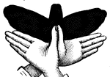

Butterfly
Hand-shadow of Butterfly
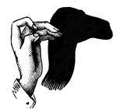

Camel
Hand-shadow of Camel
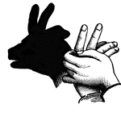

Chamois
Hand-shadow of Chamois
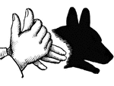

Dog
Hand-shadow of Dog
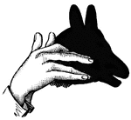

Donkey
Hand-shadow of Donkey
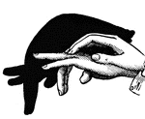

Elephant
Hand-shadow of Elephant
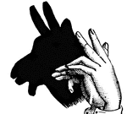

Goat
Hand-shadow of Goat
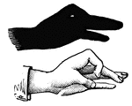

Goose
Hand-shadow of Goose
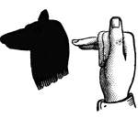

Hound
Hand-shadow of Hound
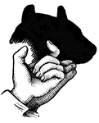

Ox
Hand-shadow of Ox
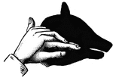

Pig
Hand-shadow of Pig
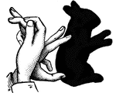

Rabbit
Hand-shadow of Rabbit
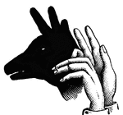

Reindeer
Hand-shadow of Reindeer
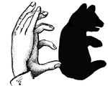

Teddy Bear
Hand-shadow of Teddy Bear
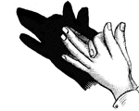

Wolf
Hand-shadow of Wolf

SUMMARY:
The possibilities are endless. Exercise safety when playing games in a darkened arena by clearly defining the play area and have lighting readily available to lessen the fears of younger players. Glow sticks can be cheaply obtained from places such as “Dollar Stores” and can help allay fear. Continuing to encourage outside play, whether daylight or dark, helps us keep the “outing” in “Scouting”.

